Scrutiny

Annual

Report

2018-2019



Contents

Foreword 3

Report from the Overview and Scrutiny Committee 4

Report from Performance and Finance Scrutiny Sub-Committee 7

Report from the health scrutiny lead members and health and social care scrutiny sub-committee 8

Report from the People Leads 10

Report from the Community Leads 11

Report from the Resources Leads 12

Call-in committees 13

# Foreword

Following the local elections in May we have taken over the mantle of Chair and Vice-Chair of scrutiny and welcomed a new cohort of scrutiny councillors along with some returning scrutiny Councillors. The start of the new municipal year was also a great opportunity to implement some changes to scrutiny in Harrow following our work with the Centre for Public Sector Scrutiny in 2017 and raise the profile of scrutiny amongst new Councillors.

Our vision for scrutiny in Harrow is: ‘*Cross-party investigation of issues and decisions that are important to local residents’*. We have used this vision to guide the development our new work programme to ensure we have a much more equal balance between holding the Council Administration and Health partners to account and investigating issues and influencing the Council and partner’s approach to issues of concern to residents. So this year we have prioritised:

* Preventing youth violence in the borough
* Waste, recycling and flytipping
* Highways maintenance

Whilst also maintaining our oversight on the Council’s budget and the performance of Northwick Park Hospital

As in previous years, the Scrutiny Leadership Group, comprising the chairs and vice-chairs of the committees and scrutiny leads, continue to provide strategic direction to the scrutiny function and help to ensure we maintain an effective focus for our work. We are extremely grateful to all of the Councillors who have contributed to the leadership group and the scrutiny reviews this year.

We would also like to thank all the Members, officers, partners and members of the public who have contributed to our scrutiny work this year. We appreciate the time and effort you have given. If you have any suggestions for issues that you think scrutiny should look into, please do let us know.

 

Cllr Jeff Anderson Cllr Richard Almond

Chair Overview and Scrutiny Vice-Chair Overview and Scrutiny

# Report from the Overview and Scrutiny Committee

**Our Committee:** The committee has met 8 times this year. The papers and details of the outcomes from all of these meetings can be found [here](http://moderngov:8080/ieListMeetings.aspx?CId=276&Year=0). Our remit continues to be the consideration of the Council’s and our partners’ strategic direction, and major projects and policy decisions. This year we have focussed the work of the committee on the theme of waste and recycling and we are grateful for the support we have received in doing this from portfolio holders and council officers. A full list of the portfolio holders who have supported our Committee’s discussions is given at the end of this section of the annual report.

**Our Meetings:** In 2018/19, we met twice with the Leader of the Council and the Interim Chief Executive for a question and answer session to consider the budget proposals and strategic direction of the Council (in July 2018 and January 2019). We are grateful for the information which they shared with us.

The specific items which have been considered at ordinary meetings of our Committee include:

* Corporate plan 2019/2020
* Draft budget 2018/19
* Community Safety, Violence, Vulnerability and Exploitation Strategy – Annual Refresh
* Youth Justice Partnership Plan 2018-2019
* Financing of the Regeneration Programme – Scrutiny Review Financial Modelling Information and Interim Report
* Children and Families Service Complaints Annual Report 2017/18
* Adult Services (Social Care) Complaints Annual Report 2017/18
* Preventing youth crime scrutiny review
* Highways maintenance review
* Transport Local Implementation Plan 3
* Waste Management and Recycling
* Flytipping
* Technology in Waste Collection
* Scrutiny Work Programme 2018-22

**Review Programme**

We have commissioned two more detailed scrutiny investigations this year on highways maintenance and preventing youth violence. The content of the review programme is identified through the performance and Finance Sub-Committee’s deliberations or via our scrutiny leads and is discussed at the Scrutiny Leadership Group and then agreed by the Overview and Scrutiny committee.

|  |  |
| --- | --- |
| **MEETING STATISTICS (O&S)**  Committee meetings | 8 |
| Attendance by Portfolio Holders | Councillor Keith Ferry -  Deputy Leader of the Council and Regeneration, Planning & Employment Portfolio Holder  Councillor Krishna Suresh -  Community Safety Portfolio Holder  Councillor Adam Swersky -  Finance & Resources Portfolio Holder  Councillor Christine Robson -  Children, Young People and Schools Portfolio Holder  Councillor Varsha Parmar –  Environment Portfolio Holder |

1. **Preventing Youth Violence**

Purpose of review:

* To investigate how we might use all of the Council’s policies and strategies to contribute to reducing youth crime and anti-social behaviour in a more ‘Public Health approach’ to Youth Crime.
* To understand how a ‘Public Health approach’ can contribute to reducing youth violence, to identify changes we could make to Council policies and strategies so they contribute to the reduction in youth crime and ASB.
* To understand what the drivers are behind the rise in youth crime in Harrow; the profile of young offenders and victims of youth crime and ASB in Harrow; and the impact of the tri-borough BCU model is having on the resources available to the local police to put into tackling this agenda.
* To inform the re-commissioning of the Council’s London Crime Prevention Fund projects and the refresh of the VVE strategy.
* To safeguard young people in care from knife carrying/crime and from gang culture.
* To investigate the links between Knife crime, gangs and child sexual exploitation.
* To investigate the better use of intelligence to target key people to stop youth violence and deter involvement.

Scrutiny recommendations:

* Recommendations will be made in June 2019.

**Response to the Scrutiny Review Panel Report on Preventing Youth Violence**

Cabinet’s response will be received in July 2019.

1. **Highways Maintenance**

Purpose of review

* To establish the nature of residents’ concern about the condition of roads in Harrow and other highways issues, as raised in the Residents’ Survey 2017.
* To understand how Harrow’s schedule of planned highways maintenance works is formulated and understand the criteria, including financial, for determining in what way works are carried out.
* To ascertain if and how the Council coordinates different types of planned works to roads and pavements.
* To ascertain if and how utilities companies coordinate planned works with the council.
* To investigate how council policies around dropped kerbs and enforcement impact upon the conditions of Harrow’s roads and pavements.
* To examine the quality assurance around contractors’ performance on highways maintenance, including enforcement by the council of its contractual rights.
* To understand how planned works and their progress are communicated to residents.
* To understand the sources of funding and associated pressures, including TfL involvement, that affect Harrow’s highways maintenance programme.

Scrutiny recommendations:

* Recommendations will be made in June 2019.

**Response to the Scrutiny Review Panel Report on Highways Maintenance**

Cabinet’s response will be received in July 2019.

# Report from Performance and Finance Scrutiny Sub-Committee

**Our Sub-Committee:**

The Performance and Finance Scrutiny Sub-Committee looks in detail at how the Council’s services are performing in-year. We monitor service and financial performance by analysing data and then requesting briefings or details of action plans where necessary. The Sub-Committee can make recommendations for improvement and make referrals to the Overview and Scrutiny committee if further work is needed. This work includes, for example, regular review of the Cabinet’s Revenue and Capital Monitoring report. In addition, we can decide to review and monitor the performance of the Council’s partners. The papers and details of the outcomes from all our committee meetings can be found here.

**Our meetings:**

Our regular Chair and Vice-Chair’s briefings on corporate performance are the main drivers for the work programme of the Sub-Committee. Our main areas of interest in 2018-19 have been:

* Revenue and Capital Monitoring 2017/18
* Annual Equalities Report 2018/19
* 12 month update on Scrutiny’s review of Homelessness
* Capital Programme 2019/20 - 2020/21
* Revenue Budget 2019/20 and Medium Term Financial Strategy 2019/20 – 2021/22
* Revenue and Capital Outturn 2017/18 & 2018-19 Revenue Monitoring as at 31st May 2018

|  |  |
| --- | --- |
| MEETING STATISTICS  Committee meetings | 3 |
| Attendance by Portfolio Holders | Cllr Phillip O’Dell  Portfolio Holder for Housing  Cllr Adam Swersky  Portfolio Holder for Finance |

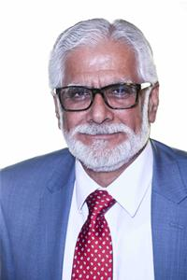 [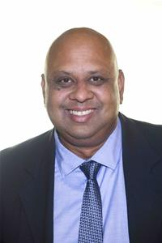](https://www.bing.com/images/search?view=detailV2&ccid=pS8nSbEP&id=49BFD761F176CC196A60B0881EFBB7221A2EC383&thid=OIP.pS8nSbEPdmov3t-UacQ7-QHaKp&mediaurl=http://www.harrow.gov.uk/www2/UserData/8/2/9/Info00010928/smallpic.jpg&exph=105&expw=73&q=richard+almond+harrow&simid=607987532609687481&selectedIndex=0&adlt=strict)

Cllr Ghazanfar Ali Cllr Pritesh Patel

Chair Performance and Finance sub-committee Vice-Chair Performance and Finance

sub-committee

# Report from the health scrutiny lead members and health and social care scrutiny sub-committee

**Our Sub-Committee:**

The Health and Social Care Sub-Committee considers health, social care and wellbeing issues key to Harrow residents on a local, London-wide and national level. The aim of our work is to provide strategic support and a resident’s perspective to the local CCG and NHS who strategically plan local services around access to primary care. We have also sought to identify what we councillors as community leaders can do to encourage residents to make best and most appropriate use of the healthcare resources available to them in Harrow.

**Our Work this Year:**

Much of our scrutiny activity undertaken in 2018-19 focused on the performance of Northwick Park hospital that serves the residents of Harrow given its second consecutive ‘requires improvement’ CQC inspection report. We also focussed on the borough’s dementia Strategy, changes to walk-in services at Alexandra Avenue and Healthwatch Harrow’s report into diabetes. We continue our on-going participation in the Joint Health Overview and Scrutiny Committee that scrutinises the implementation of “Shaping A Healthier Future” (SaHF) – the NHS programme which is implementing significant re-configuration of acute healthcare in North West London and creating an integrated care system in NW London as well as the NHS Sustainability and Transformation Plan.

**Our Sub-Committee meetings:**

Our main areas of interest in 2018-19 have been:

* Scrutiny Review of Access to Primary Care in Harrow – follow up on implementation of recommendations;
* Dementia Friendly Housing Scrutiny Review – discuss with Harrow CCG on the Review’s findings and recommendations;
* Home First and Hospital Transfer Red Bag Schemes;
* Healthwatch Harrow Annual Report 2017-18;
* Diabetes Care – Report by Healthwatch Harrow;
* Reference from Cabinet – Response to the Scrutiny Review on Dementia Friendly Housing;
* Draft Dementia Strategy 2018-2021, Harrow CCG and Harrow Council;
* Changes to Walk-in Services at Alexandra Avenue Health and Social Care Centre;
* Harrow Safeguarding Adults Board (HSAB) Annual Report 2017/18;
* London North West Healthcare NHS Trust – CQC Inspection Report;
* CQC Progress Report including Actions from the Quality Summit;
* Alexandra Avenue GP Access Centre – Changes to Walk-In Services and the impact of changes;
* North West London Joint Health Overview and Scrutiny Committee updates.

|  |  |
| --- | --- |
| **MEETING STATISTICS** (HEALTH)  Committee meetings | 2 |
| Attendance by Health Partners | Ash Verma – Chair Healthwatch Harrow  Javina Seghal - Chief Operating Officer of the NHS Harrow CCG  Lennie Dick, Head of Mental Health Services at the CCG  Adam Macintosh, Harrow CCG  Simon Crawford – Director of Strategy, LNWHT |

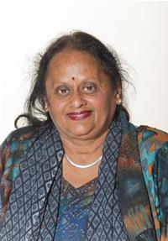 

Cllr Rekha Shah Cllr Vina Mithani

Chair of Health and Social Care Performance Lead for Health

Vice-Chair of Health and Social Care Scrutiny Sub-committee



Cllr Michael Borio

Policy Lead for Health

# Report from the People Leads

In 2018/19, we addressed a range of important issues that affect children and young people in Harrow. We have had meetings with the Corporate Director of Children’s Services and Officers. The issues we have raised and discussed include:

**Housing Needs**

We have continued to monitor the housing need. The housing service and Children’s and Families Services will continue to work in partnership and actively manage and respond to care leavers’ housing needs.

**Education, Health and Children Looked After** The Virtual head has continued to work hard to improve the education of Children Looked After and continual progress is being made especially with schools out of borough which is a challenge.

**Youth Offending Team**

We have continued to monitor how the action plan is being implemented and the impact it is having.

**School Expansion Programme**  We are continuing to monitor Keepmoat contract performance and hopefully nearing an end soon.

**Care Act**

We are still monitoring the effect on young carers and the reorganisation of the Early Intervention.

**General**

There is good and stable staff in Children’s services. We are pleased with the scrutiny review with new provider CNWL for the Health Service of children, 0-19, as the scrutiny review findings were taken into account. All under one roof with joined up thinking. We are also delighted with Harrow’s lead with Coram and adoption leading the way with other Boroughs. Hopefully, we get recompense for the chalk mines at Pinner Park School.

**Looking Ahead**

Our focus in the forthcoming year will be to continue to monitor the Early intervention reorganisation, review of health visiting and school nurses, assessments, young unaccompanied asylum seeks, checking no recourse to public funds, monitoring the efforts to increase awareness and reporting of child sexual exploitation and mutilation and plus budget implications as demand increases. Finally, the outcome of the scrutiny review of Youth Violence.

 

Cllr Jerry Miles Cllr Janet Mote

Policy lead for Children and Families Performance lead for Children and Families

# Report from the Community Leads

In the first year of this administration as Community Scrutiny Leads, we have worked together with officer and resident input to devise a work programme for this year.

A resident survey informed us about key areas of concern which we discussed with senior officers and member colleagues.

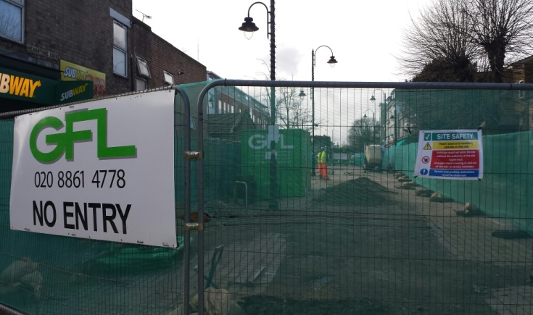Our first focus was on the often criticised Highways Maintenance which we investigated and planned with the two senior officers at our first review group meeting. Based on their input, we chose a practical approach for our scrutiny review group to view roadworks on the ground. This visit guided by our senior officer proved to be very instructive and enabled the scrutiny review members to ask/challenge informed by these observations. Our following session again hosted by the senior officer was in the offices which enabled colleagues to dig down into issues we had observed. Additionally, we were able to learn about ways of working and understand how the service delivery is achieved.

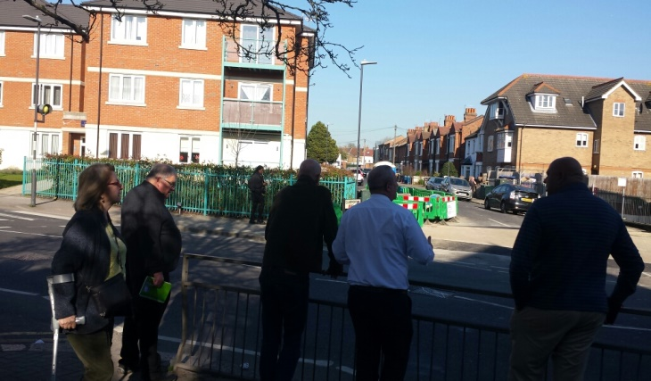

Members reviewing the borough’s road works Works at Wealdstone Square

In addition to our scrutiny review, we hold quarterly meetings with officers (Nick Powell, Jon Dalton, Rebecca Johnson, Beverly Kuchar, Jim King and Jonathan Wilson) and portfolio holders Councillors Ferry, Parmar and O’Dell, chaired by Paul Walker, having previously agreed the topics/areas we wished to focus on. This enables us to create an ongoing body of work, a simple example was fly tipping which resulted in a report to O&S, Housing and Homelessness which was presented later at a member development event and Fire Safety where further research was requested on the materials make up of another building in Harrow and in addition whether the Fire Service has resources to tackle fires in our increasing number of high rise buildings.

 

Cllr Ghazanfar Ali Cllr Jean Lammiman

Policy Lead for Community, Health & Wellbeing Performance Lead for Community, Health & Wellbeing

# Report from the Resources Leads

We have met regularly with Alex Dewsnap, Divisional Director - Strategic Commissioning, and with Jonathan Milbourn, Head of Customer Services, to discuss the performance of the Council, with the focus being around the call centre. Whilst the data shows that waiting times are acceptable, Councillors still receive a large amount of casework from residents, where there are a number of complaints regarding long waits. This is an area that needs to be monitored, especially as the Council moves more areas to web forms only.

We have also paid attention to the issue of the Police tri-borough merger, which came fully into effect towards the end of 2018. With the increase in violent crimes in London, it is vital to ensure that response times do not fall as a result of this merger. We remain concerned that as Harrow has the lowest crime rate of the three boroughs, we will as a result lose out in any decisions relating to resource allocation. At this early stage, it is too early to understand the impact of this change, but in the municipal year 2019/2020, the first year’s data of the tri-borough merger will become available, and will need to be scrutinised in detail.

We have continued to scrutinise the performance data that is made available to the improvement boards and challenged these where necessary. It is vital that this scrutiny continues, especially when services come under further strain, as budgets are cut further.

We would like to thank all the Harrow Council officers that have taken time to brief us over the last year. As always, we very much appreciate this and express our gratitude.

 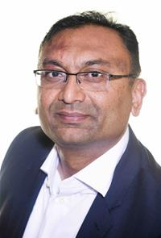

Cllr Sachin Shah Cllr Kantilal Rabadia

Policy Lead for Resources Performance Lead for Resources

# Call-in committees

* There were no meetings of the call-in committee in 2018/19